Halfway
The end of studies seems closer and closer, sometimes it is even hard to believe that I have already passed halfway of my studies. And I am really happy about it even thought I have met many wonderful people, learned so much but still I do really want to graduate and start working and using my knowledge from University in practical way.

Summer job
This summer I have spent in United Kingdom. It is my second summer in this country. I have spent more than two months there. I worked in farm with two friends from same University as I am. We also met other students from Vilnius and Kaunas, we keep in touch with them till now.
We lived in quite big caravans, 4-6 people per caravan. I have some pictures from there:
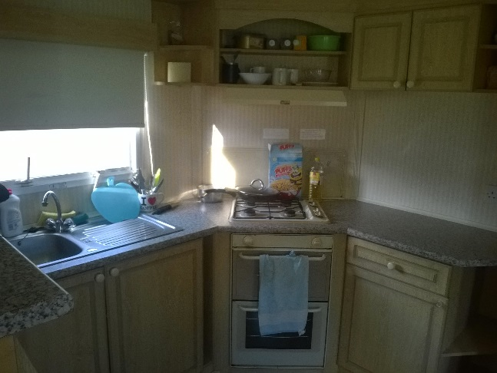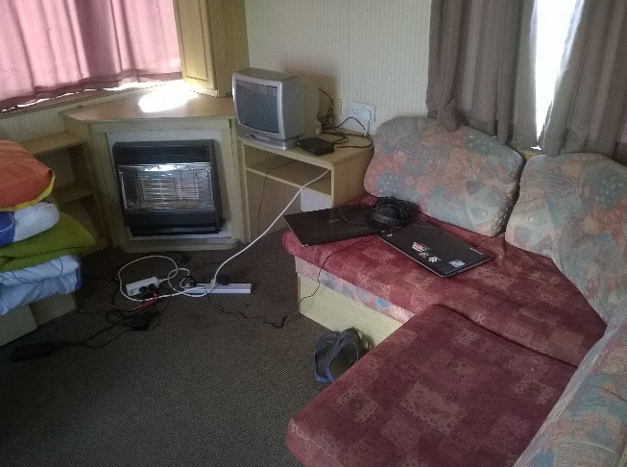
And some pictures from work:
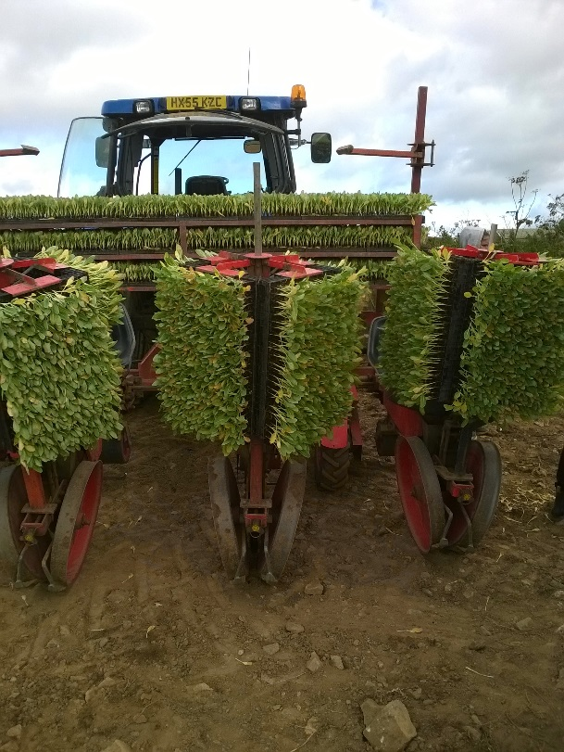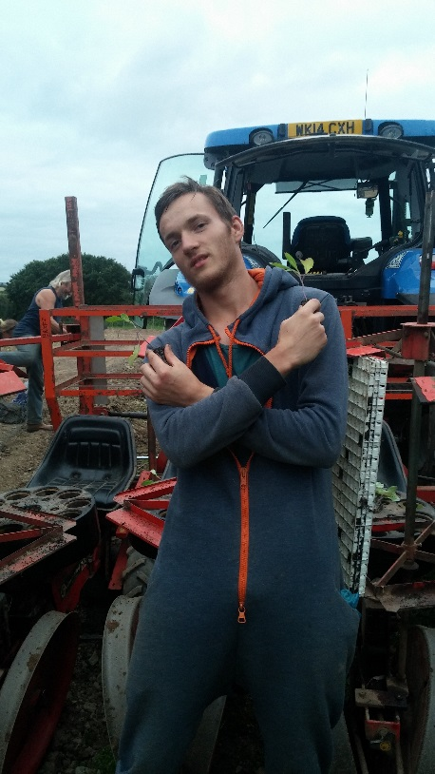

I have earned some extra money there, more than I would have earned in Lithuania. During this summer in United Kingdom was many rainy days so I had much free time which I have spent exploring nearest town (Newquay). Here is one photo from Newquay beach:
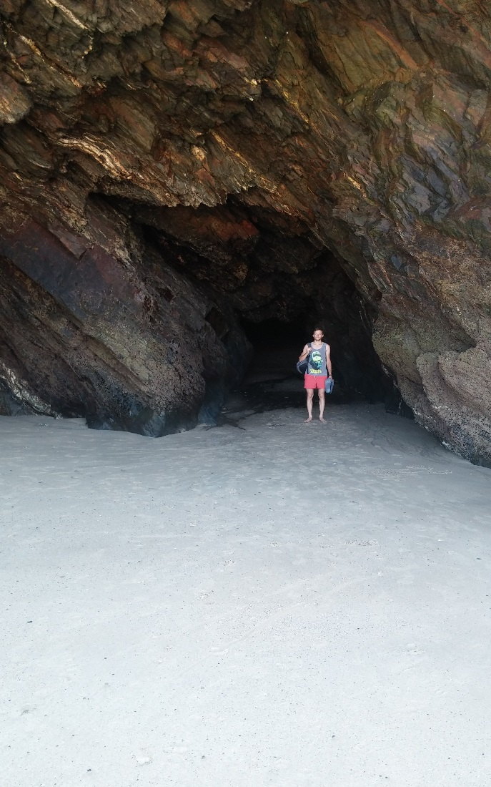
Last couple days we have spent in London, did some sightseeing and met one of my friends’ cousin. Sadly I do not have any decent photos from London.

Back to real work
Third year in Kaunas University of technology started slowly. First month or so I had mostly theory lectures with some easy tasks.
Couple weeks ago I have been in one of the biggest or the biggest video game conference in Baltic countries – GameON. It took place in Vilnius and ticket was quite cheap if you bought it long ago. During conference beside games I have met many my potential employees because there was a huge stand for game developing companies, I have talked with other programmers who work there, tried out their software.
Last couple weeks I have been studying very much, I had two or three tests every week, in most of it I did quite well. This year we will have less exams than last year because in couple academic modules (subjects or lessons, I do not know how to call it so you could understand easier) we have project works which we have to do over an academic year and account in the end of year instead of the exam.
I guess that is it for now. I will continue my studies as planned and will write another report after half year. I am very happy and thankful for your support.

